

Project Report

Easy answers to life’s toughest question, “What do you want to do?”

M-Square : An online ticket booking software

|  |  |  |
| --- | --- | --- |
|  |  |  |
| ***Submitted by-***   |  |  |  | | --- | --- | --- | | Muskan Ludhiyani | 18103258 | B8 | | Soumya Verma | 18103266 | B8 | | Amruit Pratyay | 18103247 | B8 | | Jayant Goel | 18103255 | B8 | |  |  |
|  |  |  |

Contents

Introduction 1

Why do we need it? 2

Flow Chart 4

List of Data Structures used 5

Functions used in the project 6

Algorithms of some functions 7

Result Screenshots 8

Task distribution 10

# INTRODUCTION

***M2***

Cinema-going is one of the most popular out-of-home cultural activities, affecting a serious of social, economic and cultural phenomena in modern societies. Cinemas are considered to be an integral part of cities and they contribute to the definition of a local geography and identity. They also contribute to the preservation of the collective memory, since they constitute a significant social and cultural practice linked to a specific place, which acts as a common reference or landmark for many individuals.

Cricket is a thrill both to play the game and to watch it and its importance is no less than any sporting event. So people love to watch cricket in India. Therefore providing them an easy access to book tickets for cricket match is also a really important thing we can do for them.

Through this project we present a comprehensive solution for ticket booking in multiplexes as well as stadiums. Theater management system, an online ticket selling software that is easy to understand, easy to use and offers the simplicity of fast key-press service to the customers.

Our project **“M Square”** basically manages the ticket booking process of a multiplex, and booking tickets for a cricket match providing an interface to the user to book movie/match tickets in a more easy way. The project proceeds through a sequence of well-designed forms provided with validations to ensure consistency, reliability and most importantly correctness of information fed into the data structure and file.

# WHY DO WE NEED IT?

Faced with an increasing number of customers standing in long queues outside the theatres, there was an urgent need to find an alternative. Customers desperately wanted an easy way of ordering and paying for their tickets without the delays and inconvenience of standing in long queues. We introduced a ticket booking software which would help the customers with an alternate easy way to get tickets just by pressing a key while sitting on their couches. This is surely going to affect business profits.

This powerful software program is specifically designed for theater owners, to sell tickets online. This intuitive interface makes day-to-day aspects of selling, exchanging, refunding, and reporting fast and easy for both the user and administrators. Theater management controls all back-end functionalities like, movie details, ticket rate and show time and customer information saved in a data structure and file, etc. Theater admin manages the report details like counter wise report, daily, weekly, monthly report and movie report etc.

In response to the Cinemas requirements now-a-days, we proposed an E-business solution using Codeblocks Platform which would enable movie goers to book their tickets electronically from the comfort of their office or home. With the advent of the modern age, the typical user didn't have enough time to stand in line outside the theaters. The online solution allows users to select their shows, book and pay for their tickets. This guarantees them a ticket even before they arrive at the cinema hall.

***Benefits***

The movie portal has benefited cinema sectors in many ways out of which a few have been outlaid below:

* Convenient online ticket booking through the Internet, which in turn leads to more, and repeat customers and shorter queues.
* Customers can make online ticket booking at any instance of 24 hours a day.
* Access to information and other movie-related promotional news.
* Online Brand extension by projecting a tech-savvy image, and appealing to the consumers of the generation who spend a lot of time browsing the Internet.

# FLOW CHART

# LIST OF DATA STRUCTURES USED

* **Linear queue** : a **queue** is a [collection](https://en.wikipedia.org/wiki/Collection_(abstract_data_type)) in which the entities in the collection are kept in order and the principal (or only) operations on the collection are the addition of entities to the rear terminal position, known as enqueue, and removal of entities from the front terminal position, known as dequeue.

Linear queue is used here for the seating arrangement, to check whether there are seats available in the theatre or stadium.

* **Stack** : a **stack** is an [abstract data type](https://en.wikipedia.org/wiki/Abstract_data_type) that serves as a [collection](https://en.wikipedia.org/wiki/Collection_(computing)) of elements, with two principal operations:

**Push** - adds an element to the collection

**Pop** - removes the most recently added element

Stack is used here in the movies section, to display the name of the movie you recently booked by scanning the name from the file and then displaying the name on the console.

* **2-D Array :** The two-dimensional array can be defined as an array of arrays. The 2D array is organized as matrices which can be represented as the collection of rows and columns. However, 2D arrays are created to implement a relational database lookalike data structure. It provides ease of holding the bulk of data at once which can be passed to any number of functions wherever required.

2-D Array is used here to display the seating arrangement for movies and matches.

# FUNCTIONS USED IN THE PROGRAM

Void push (char): To enter element in the stack.

Char pop (): To delete element from top of the stack.

Void display (): To display the popped items from the stack.

Void insert_new_movie (): To insert a new entry in the movies list, which is controlled by the administrator.

Void insert_new_match (): To insert a new entry in the matches list, which is controlled by the administrator.

Void view_available_movies (): To view the available movies list.

Void view_available_match (): To view the available matches list.

Void book_ticket (): Allows user to choose a movie from the list, display the total amount and fill in their details.

Void book_ticket2 (): Allows user to choose a match from the list, display the total amount and fill in their details.

Void old_record (): To store all the transactions of movie booking.

Void old_record2 (): To store all the transactions of match booking.

Void view_available_pt (): To display the point table of IPL.

# ALGORITHMS OF SOME FUNCTIONS

**Insertion of new movie/match:**

* Enter administrator’s ID and Password.
* If Password entered is 1234:

*For movies* – Enter movie code, movie name, release date & ticket price, to be stored in a file named “data.txt”.

*For matches* – Enter match no., rival teams, day, date, ticket price & venue, to be stored in a file named “IPL.txt”.

**Booking tickets for movie/match:**

* Movies/Matches list is displayed after reading it from the file.
* Input movie/match code as displayed.
* Compare from the file using strcmp.
* If record found, print the details on the console.
* Input user’s name and mobile number.
* Display seating arrangement and input seats.
* Booking is successful if seats are available.

# RESULT SCREENSHOTS

**For Movie tickets:**

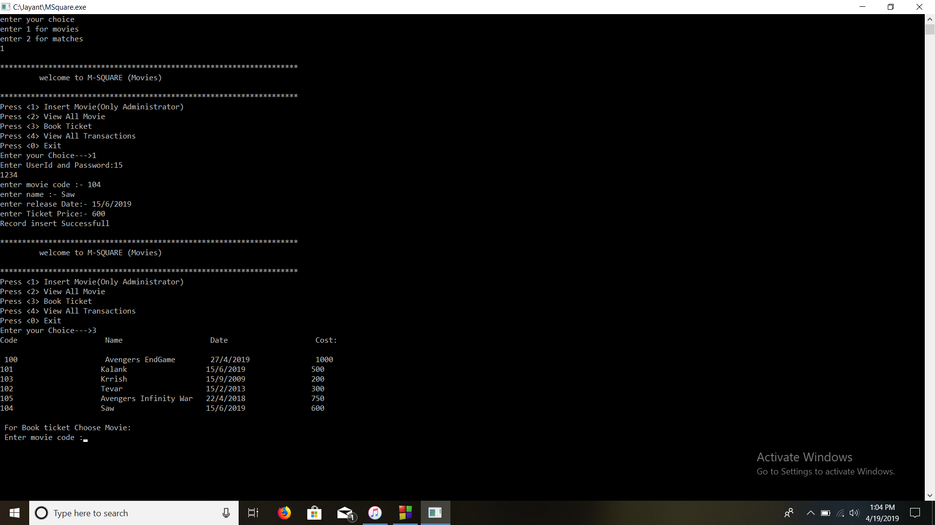

**For Match tickets:**

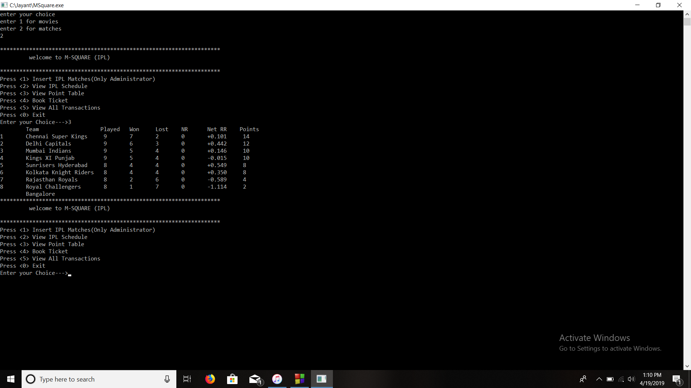

# TASK DISTRIBUTION